Histogram with Point visual is nothing but the combination of histogram and point chart to show histogram along with points.

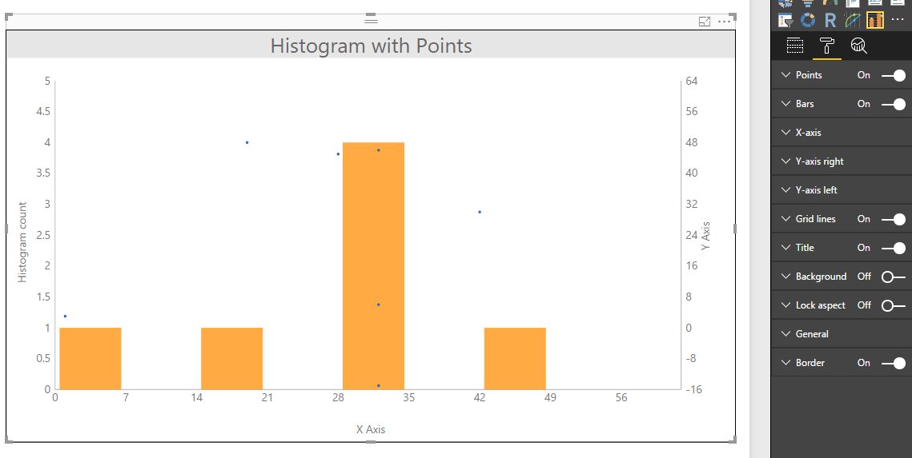

Configurations:

1. Points (To enable or disable points in the visual)
   1. Tooltip: To enable or disable the tooltip for points
   2. Color: To set points color
2. Bars (To enable or disable histogram in the visual)
   1. Tooltip: To enable or disable the tooltip for histogram bars
   2. Color: To set histogram bars color
3. X-axis
   1. Title: To enable or disable title of X-axis
   2. Title text: To set title of X-axis
   3. Labels: To enable or disable labels on X-axis
4. Y-axis-right (Y-axis of points)
   1. Title: To enable or disable title of right Y-axis
   2. Title text: To set title of right Y-axis
   3. Labels: To enable or disable labels on right Y-axis
5. Y-axis-left (Y-axis of histogram)
   1. Title: To enable or disable title of left Y-axis
   2. Title text: To set title of left Y-axis
   3. Labels: To enable or disable labels on left Y-axis
6. Grid lines
   1. X Axis: To enable or disable grid lines of X axis
   2. Y Axis: To enable or disable grid lines of Y axis